
UNIVERSITY OF NAIROBI

UNIVERSITY EXAMINATIONS 2023/2024

SECOND YEAR EXAMINATION FOR THE DEGREE OF BACHELOR OF SCIENCE IN CIVIL ENGINEERING
SCI 3265 – COMPUTER SCIENCE III

DATE: 15TH FEB, 20234 TIME: 2:00 P.M. – 4:00P.M

INSTRUCTIONS TO CANDIDATES
- Answer questions ONE from section A(Compulsory)

- Answer ANY TWO questions from Section B
- Implement your programs in either C, C++ or PYTHON.

SECTION A: (COMPULSORY-30 MARKS)
Question One
(a) Explain the following terms as used in programming: -
(i) Computer Program
a set of instructions that tell a computer what to do
(ii) Programming
process of creating computer programmes
(iii) Programming language
special code that follows syntax that help one write computer instructions (3 Marks)

(b) Outline Four factors that are key in evaluating a programming language for an application.
Purpose
timeline
complexity
long term cost
(4 Marks)
(c) Explain the role of the following programming tools in a computer system: -
- Assemblers,
- Interpreters
- Compilers.
- Mark)
(d) With appropriate diagrammatic flowchart, differentiate the use of if and if-else control structures.

Rhombus
rectangle
circle
diamond shape

(3 Marks)
(e) Data type determines the set of values that a data item can take and the operations that can be performed on the item. Identify four data types that are generic to any structured programming.
Str
int
lists
(4 Marks)

(f) With reference to programming, distinguish between Source program
and Object code. (2 Marks)

(g) Replace *** in the following code with a statement that will print a message like 'Congratulations! Your grade of 91 earns you an A in this course'. Your statement should print the value stored in the variable grade:

if grade >= 90:
print(f”Congratulations! Your grade of {grade} earns you an A in this course”)
(3 Marks)
(h) Just like engineering design, programming flowcharts are fundamental in the early stages of computer program design. With appropriate illustrations, explain the four flowchart structures.
(4 Marks)

(i) Given,

#include int main() { int i, j; for (i=9; i<=10; i++) { for (j=1; j<=10; j++) { printf("%d * %d = %d\n",i ,j, i*j); } } return 0; }

Required. Trace the code and write the output of the entire program.
(4 Marks)

Section B Attempt Any Two Questions (40 Marks)

Question Two

(a) State the purpose of each of the following escape sequence characters as used in
Programming.

(i) \n
(ii) \t (2 Marks)

(b) Explain three salient features of an algorithm. (3 Marks)

(c) Outline three common types of errors that can be found in a computer program.

(3 Marks)

(d) Every year, if an employee receives a good job performance review, they get a raise of 3% on their wages. In turn, if they receive a suboptimal performance review, their wages are deducted by 3%. Consider an employee starting with an hourly wage of $10. Calculate how much this employee is earning after 5 years of consistent good reviews and after 2 years of bad reviews. Use the following formula to calculate these wages:
w = o(1 + p)^{n}
where
w is the new hourly wage,
o is the original hourly wage,
p is the percentage increase or decrease, and
n is the number of years with an increase or decrease in hourly wage.

- Represent the above problem using a program flowchart. (6 Marks)

- Write a computer program that will implement the flowchart drawn in (I). (6 Marks)

Question Three

(a) Every word in a C program is either an identifier or a keyword. State any four rules for forming identifiers. (2 Marks)
(b) Write a script that displays the following Christmas tree. Use for loops to generate the patterns.
*
***
*****
*******
*********
*
*
*
****** (4 Marks

(c) During the COVID-19 season, it was important to keep track of the number of infections. Write a script in which the user can input the number of reported infections per day over one week. Calculate the total, average, smallest, and largest of these values. Write your script using a loop structure. (7 Marks)

(d) Implement the following decision table using a multiple-alternative if statement . Assume that the wind speed is given as an integer.
Wind Speed (mph) Category
below 25 not a strong wind
25–38 strong wind
39–54 gale
55–72 whole gale
Above 72 hurricane (7 Marks)

Question Four
(a) Computer-assisted instruction (CAI) refers to the use of computers in education. Write a script to help an elementary school student learn multiplication. Create a function that randomly generates and returns a tuple of two positive one-digit integers. Use that function’s result in your script to prompt the user with a question, such as
How much is 6 times 7?
For a correct answer, display the message "Very good!" and ask another multiplication
question. For an incorrect answer, display the message "No. Please try again." and let
the student try the same question repeatedly until the student finally gets it right. (8 Marks)

(b) The following matrix contains the number of mobile phones sold in an electronic shop located along Moi Avenue, Monday to Friday for four weeks in the month of June 2023.

1 2 4 7 2

7 5 2 9 1

4 5 2 8 3

4 7 8 8 2

Write a program that will initialize a two-dimensional array with the values in
the matrix and then: -
(i) Compute the total number of mobile phones sold in the First week (first Row).
(ii) Compute the total number of mobile phones sold on Wednesdays (third column).
(iii) Compute the total number of mobile phones sold in four weeks. (12 Marks)

Question Five.

According to Riverside Engineering Sacco, dividends are usually calculated on prorated, meaning each contribution from your payslip earns you interest. Below is the formula used;
Opening Balance (as at December 2022) = OB
Monthly Contribution =MC
Let’s assume your OB is Ksh 300,000 and your MC is Ksh 5000 and an interest on deposits is 10 %.
You first compute earnings from your OB and then proceed to compute your earnings from your monthly contributions as tabled below.
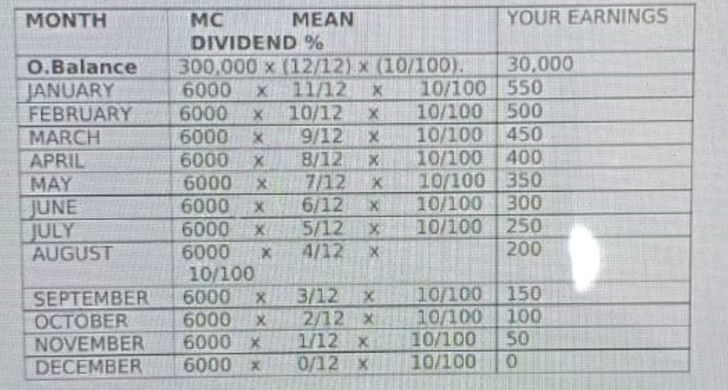

Gross dividends then summing your earnings for the whole year. Net dividends is gross dividends minus 5% withholding Tax. Withholding tax is a tax deducted from certain incomes such as management, professional and training fees, consultancy fees, legal fees etc and in this case from dividends.
Required.

Following SDLC in software engineering, provide a solution for the sacco. Use all the necessary tools from flowcharts to code implementation.
(20 Marks)

END

